**University of Engineering and Technology, Peshawar**

Department of Computer Systems Engineering.

*Course : CSE-303 Microprocessor Based System Design*



**Zainab Khalid 19** PWCSE **1743**

Section A

Batch 21 (Spring_2022)

**Submitted to** Dr, Bilal Habib

**Task 02**

**A. Generate a signal on pin P1.2 having a frequency equal to 200 Hz with a duty cycle of 40%.**

**B. When a user presses a button at P1.1 the frequency changes to 100Hz with a 60% duty cycle.**

**C. Show it on an oscilloscope. Use only Proteus.**

**D. Each time a user presses a button the signal toggles from A to B and then B to A on the next subsequent press.**

**Task 01 (A)**

**Generate a signal on pin p1.2 with frequency 200Hz and duty cycle 40%**

**Source Code**

#include <reg51.h>

#include <stdio.h>

sbit pin = P1^0;

void Delay(unsigned int delay);

int main(){

while(1){

pin = 1;

Delay(2);

pin = 0;

Delay(3);

}

return 0;

}

void Delay(unsigned int delay){

unsigned int i;

unsigned int j;

for (i = 0; i<delay; i++){

for (j = 0; j<122; j++);

}

}

**Task 02_b**

**User presses a button at pin p1.2 with frequency 100hz and duty cycle 60%**

**Source Code**

#include <reg51.h>

#include <stdio.h>

sbit PIN = P1^1;

sbit LED = P1^2;

void Delay(unsigned int delay);

int main(){

while(1){

if(PIN == 0){

LED = 1;

Delay(6);

LED = 0;

Delay(4);

}else if (PIN == 1){

LED = 1;

Delay(2);

LED = 0;

Delay(3);

}else;

}

return 0;

}

void Delay(unsigned int delay){

unsigned int i;

unsigned int j;

for (i = 0; i<delay; i++){

for (j = 0; j<123; j++);

}

}

**Task 02_c**

**Schematic Diagram**

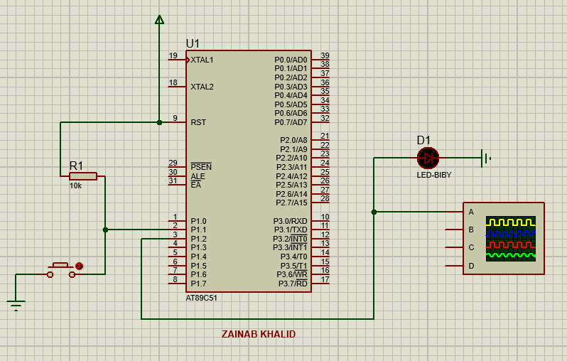

**Oscilloscope (Wave Form)**

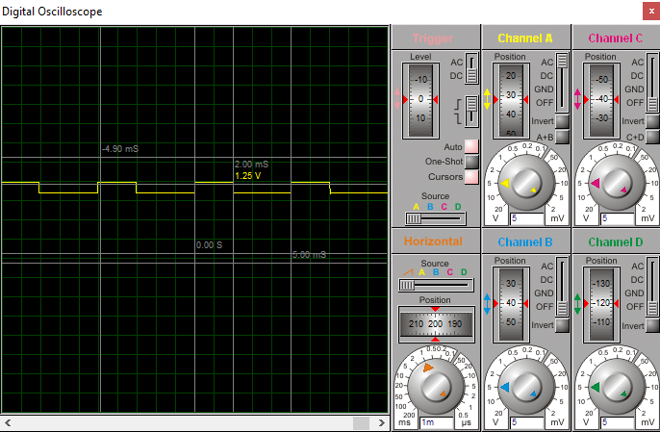

**Task 02_d**

**Schematic Diagram**

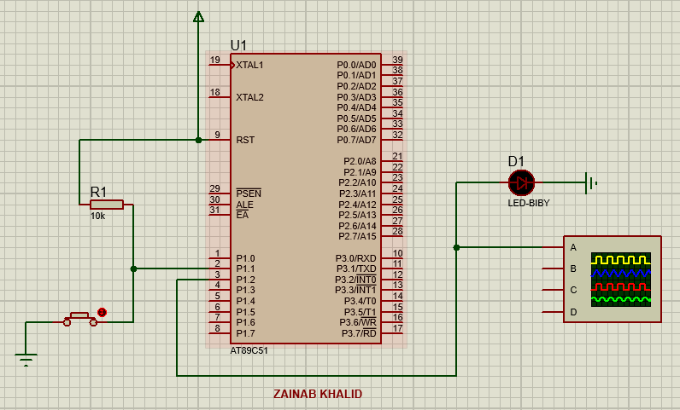

**Oscilloscope (Wave Form)**

